Header

Definition:
# Source: AI Source: Provided by: [Data Path: Persons Table -> ID Column: 1, Name_En Column: Motasem Essam] -> From: [Chatgpt (GPT‑5 Mini)] on [2/12/2026]
A Header is the top section of a web page that usually appears on all pages of a website and contains key elements for navigation and branding.

Simple Definition
# Source: AI Source: Provided by: [Data Path: Persons Table -> ID Column: 1, Name_En Column: Motasem Essam] -> From: [Chatgpt (GPT‑5 Mini)] on [2/12/2026]
Header = the top part of a web page that shows the logo, site name, and main navigation.

What a Header Usually Includes
# Source: AI Source: Provided by: [Data Path: Persons Table -> ID Column: 1, Name_En Column: Motasem Essam] -> From: [Chatgpt (GPT‑5 Mini)] on [2/12/2026]
- Logo / Site Name – identifies the website or brand
- Navigation Menu – links to main pages like Home, About, Contact
- Search Bar (optional) – allows users to search the site
- Call-to-Action (optional) – buttons like “Sign Up” or “Login”
- Contact Info or Icons (optional) – phone, social media links

Purpose of a Header
# Source: AI Source: Provided by: [Data Path: Persons Table -> ID Column: 1, Name_En Column: Motasem Essam] -> From: [Chatgpt (GPT‑5 Mini)] on [2/12/2026]
- Provide branding (logo / site name)
- Allow easy navigation to important pages
- Make the website recognizable and professional
- Improve user experience by keeping navigation visible

Examples
# Source: AI Source: Provided by: [Data Path: Persons Table -> ID Column: 1, Name_En Column: Motasem Essam] -> From: [Chatgpt (GPT‑5 Mini)] on [2/12/2026]
- E-commerce site → logo + Home, Shop, Cart links
- Blog → logo + Home, Blog, About links
- Corporate site → logo + Services, Contact, Careers links

Difference Between Header and Navbar
# Source: AI Source: Provided by: [Data Path: Persons Table -> ID Column: 1, Name_En Column: Motasem Essam] -> From: [Chatgpt (GPT‑5 Mini)] on [2/12/2026]
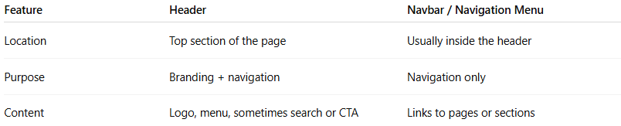
Feature | Header | Navbar / Navigation Menu
Location | Top section of the page | Usually inside the header
Purpose | Branding + navigation | Navigation only
Content | Logo, menu, sometimes search or CTA | Links to pages or sections

